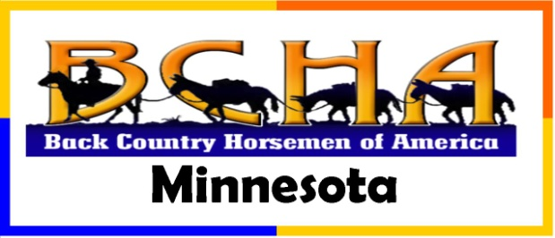
Instructions for filling out Volunteer Hours forms
We encourage everyone to keep a log of your volunteer efforts to support public horse trails and campgrounds around Minnesota. BCH-MN will help you by providing these forms and instructions for what to report to us. Then we will total up all of the efforts around MN for the year and publish them to all of the responsible government agencies in order to insure that they are aware of the significance to their recreational programs. We will also submit the Minnesota efforts to the national volunteer hours report that Back Country Horsemen of America, BCHA, publishes each year.
You will find these 3 documents listed under the Volunteers tab:
- BCH-MN – Vol efforts definitions.docx
- BCH-MN – Vol Hours template.pdf
- BCH-MN – Vol Hours template.xls
You can print out copies of the first 2 documents to pass out to your volunteer leaders and you can record your hours on a paper copy of the pdf form if that is most convenient for you.
If you are skilled at using EXCEL you can open the xls spreadsheet version of the template and record your hours there directly.
If you use the xls form, send your reports to bchminnesota@gmail.com and freese.diane@outlook.com
If you use the pdf form, mail a paper copy to: Diane Freese, 720 25th St SW, Rochester MN 55902-2213

If you need further assistance please contact me at any time.
Diane Freese - BCH-MN Vice President and Volunteer hours coordinator
Freese.diane@outlook.com 507-319-5808
720 25th St SW, Rochester MN 55902

BCH-MN Vol hours instructions.docx on www.bchmn.org/volunteers.html

